THE SOLEMNITY OF PENTECOST
May 18/19, 2024
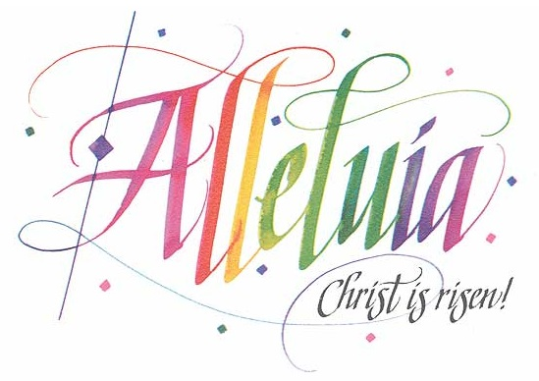
10:30 a.m. Fr. Paul- Assisted by Deacon Harbey

St. Michael Poplar Springs
Mount Airy, MD
10:30 a.m. in church will be live-streamed.

Prelude “Holy Spirit, Come Now”
Jesse Manibusan
Breaking Bread Number 194
Text: English, Jesse Manibusan; Spanish tr., Santiago Fernández, © 2006, 2011, Jesse Manibusan and Santiago Fernández. Music © 2006, Jesse Manibusan. Text and music published by Spirit & Song®, a division of OCP. All rights reserved.
Used with permission. Reprinted under OneLicense.net #A-727260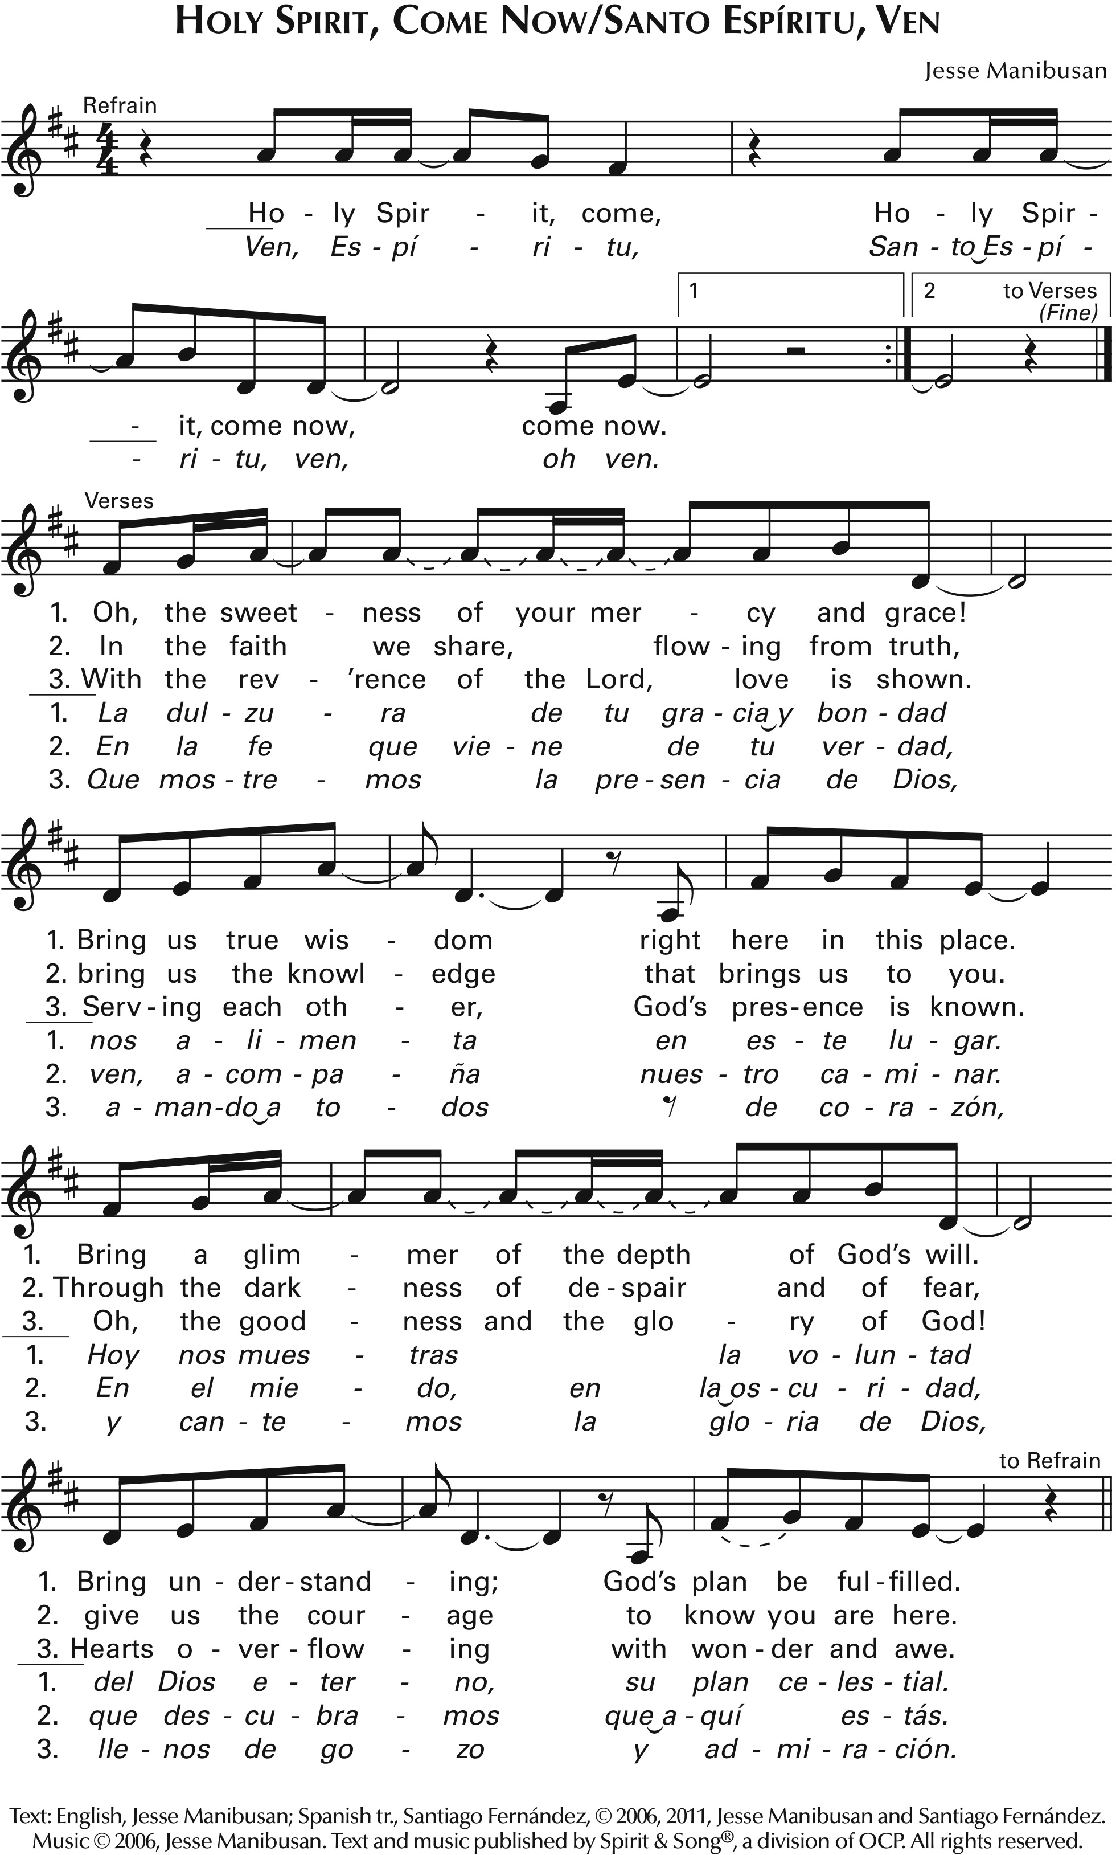

MUSICIAN: Good evening/morning/afternoon! Welcome to St. Michael Poplar Springs for the celebration of Pentecost!

Be sure you have picked up a worship aid. You will find the Pentecost Sequence here. Many centuries ago there were sequences – a poetic text composed for special celebrations – for many feasts. Today there are four that are still often used, and the Church makes them a part of the liturgy for Easter Sunday and Pentecost Sunday. The sequence follows the Second Reading and then is followed by the Gospel Acclamation – or “Alleluia.” The setting we sing today is on the worship aid and after the final verse you’ll notice the cantor beginning to sing, “Alleluia.” When you hear this, please stand, repeat the alleluia, listen to the singing of the Gospel Acclamation verse, and then repeat the alleluia.

10:30 – We welcome to those who join us via livestream! You will find a worship aid for your use at our web page.

ALL MASSES:
Before Mass begins,
let us all take a moment to silence our mobile devices
and come to a quiet awareness of God’s presence here, remembering the needs of our loved ones and our world, giving thanks for the many blessings
we have received this week.
< PLEASE PAUSE to “remember.”>

Please stand and offer welcome to those around you…

Today our presider is:
10:30 – our pastor, Father Paul. He is assisted by Deacon Harbey.

ALL MASSES- Please turn in the Breaking Bread book to song number 171, “Alleluia! Love Is Alive,” number one-seven-one. Let us sing together.

INTRODUCTORY RITES
Gathering Song “Alleluia! Love Is Alive”
Steve Angrisano, Jesse Manibusan, Sarah Hart
Breaking Bread Number 171
© 2012, Steve Angrisano, Sarah Hart, and Jesse Manibusan.
Published by Two by Two Ministries and Spirit & Song®, a division of OCP.
Administered by Spirit & Song®, a division of OCP. All rights reserved.
Used with permission. Reprinted under OneLicense.net #A-727260
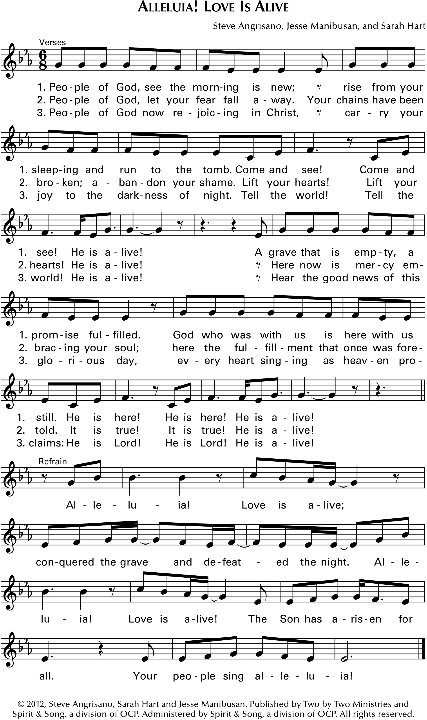
Greeting

Sign of the Cross

Penitential Act

Gloria “Glory to God” from Mass of Christ the Savior
Dan Schutte
Text © 2010, ICEL. All rights reserved. Used with permission.
Music ©2007, 2009, Daniel L. Schutte, Published by OCP.
All rights reserved. Used with permission. Reprinted under OneLicense.net #A-727260
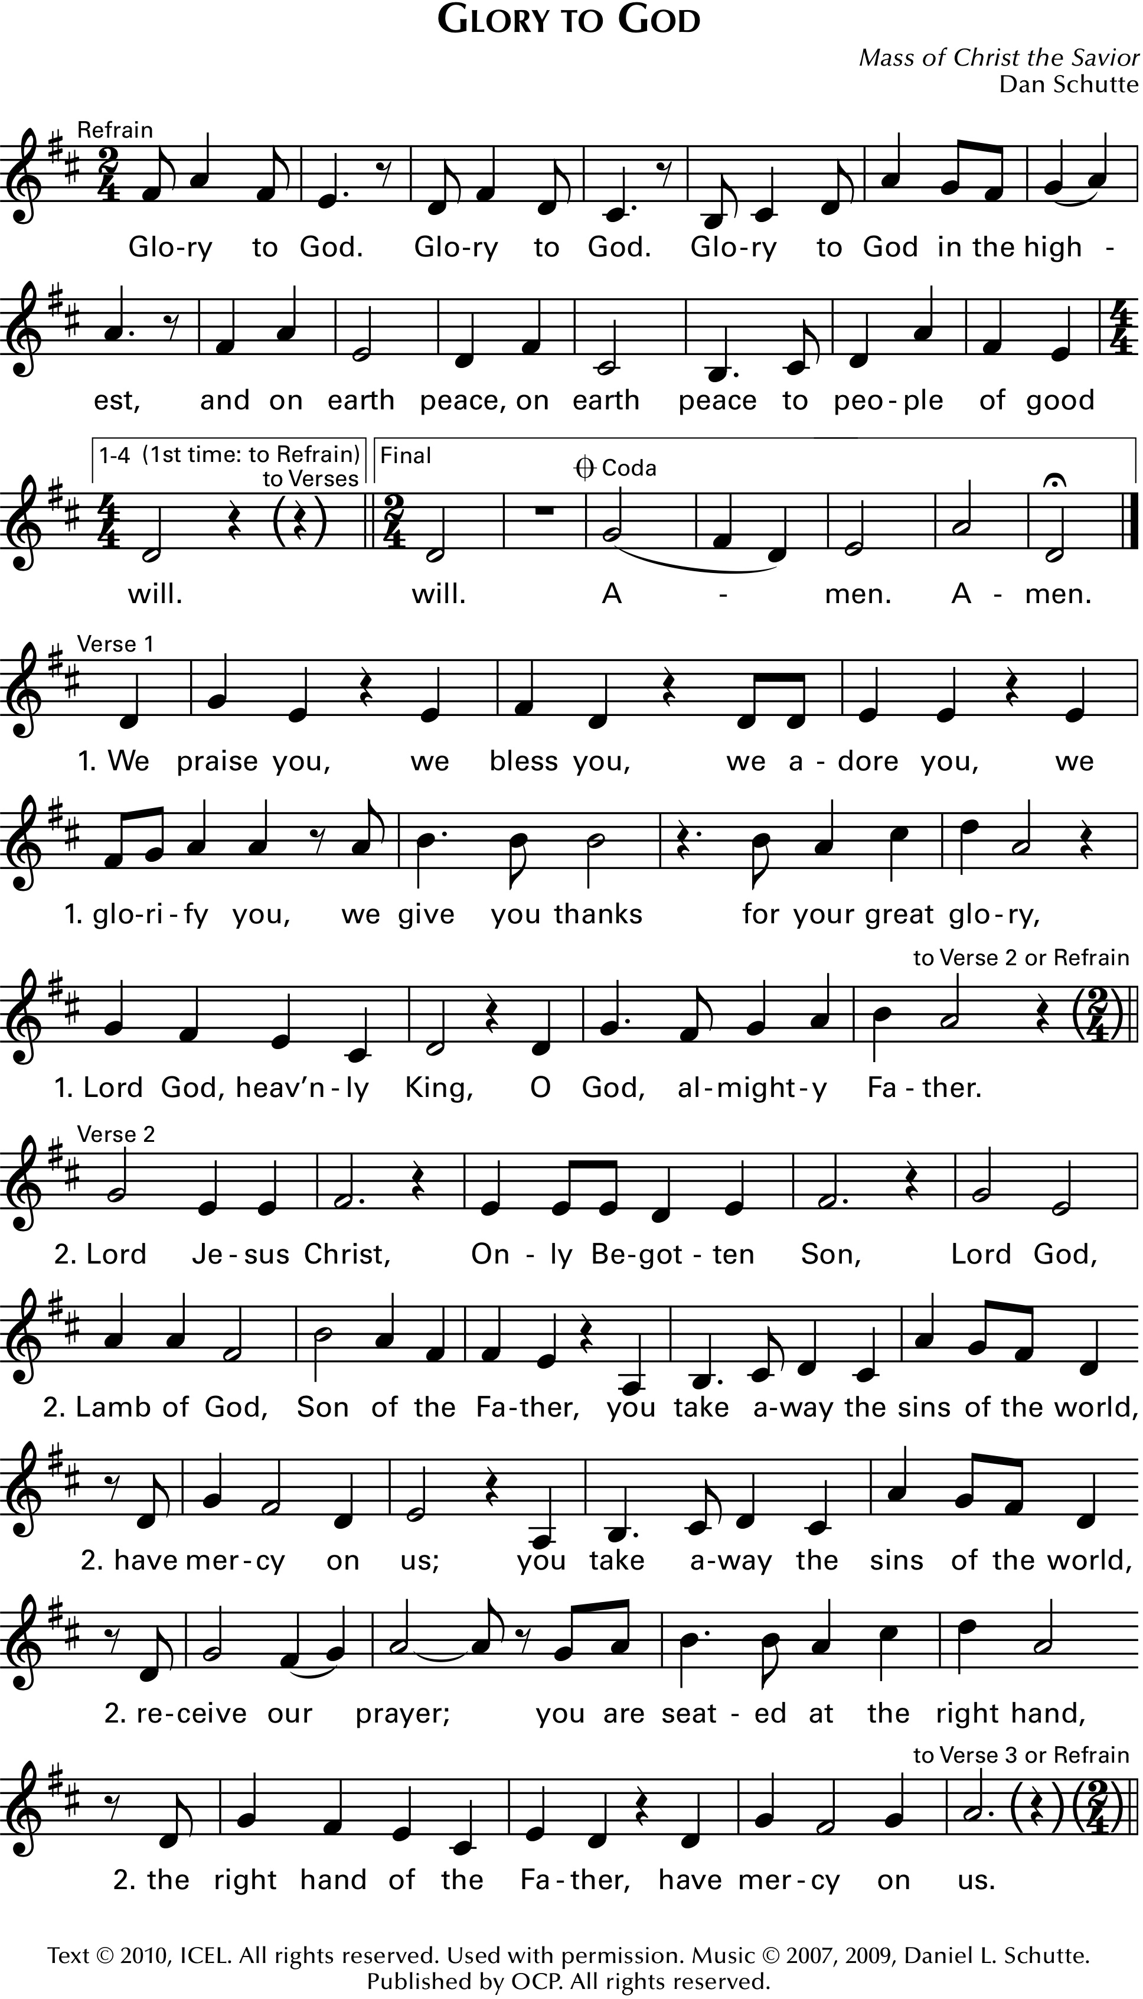
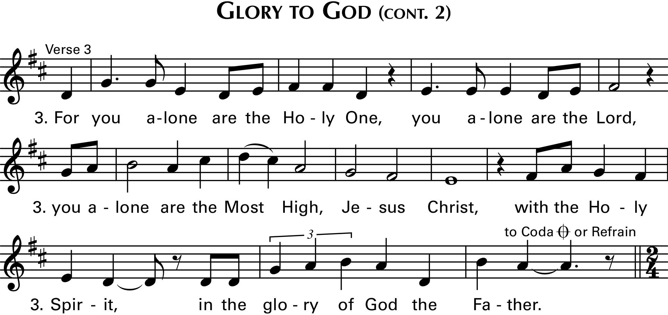

Collect

LITURGY OF THE WORD
First Reading Acts of the Apostles 2: 1 - 11

Responsorial Psalm Psalm 104:
“Lord, Send Out Your Spirit
and Renew the Face of the Earth”
Steve Angrisano
Text © 1969, 1981, 1997, ICEL. All rights reserved. Used with permission.
Music © 2016, Steve Angrisano. Published by OCP. All rights reserved.
All rights reserved. Reprinted under OneLicense.net #A-727260 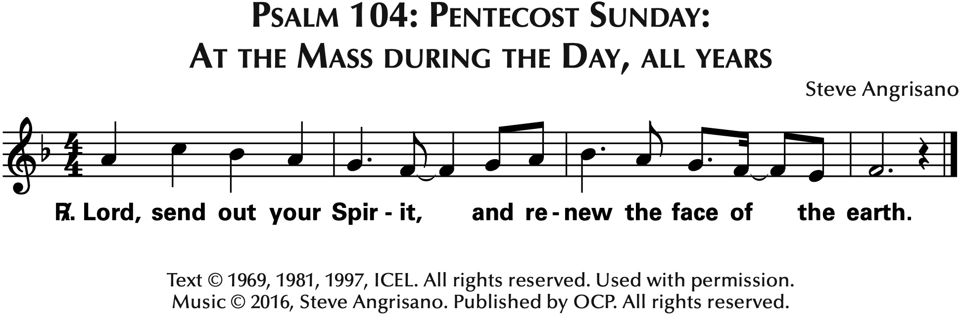

Second Reading 1 Corinthians 12: 3b – 7, 12 - 13
Pentecost Sequence Jesse Manibusan and Remi Fonseca Bauer
Text: Veni, Sancte Spiritus; Poetic Sequence for Pentecost,
fr. The Roman Missal © 1964, The National Catholic Welfare Conference, Inc. (now US Conference of Catholic Bishops).
All rights reserved. Used with permission.
Music © 2014, 2017, Jesse Manibusan and Remi Fonseca Bauer. Published by OCP.
All rights reserved. Reprinted under OneLicense.net #A-727260
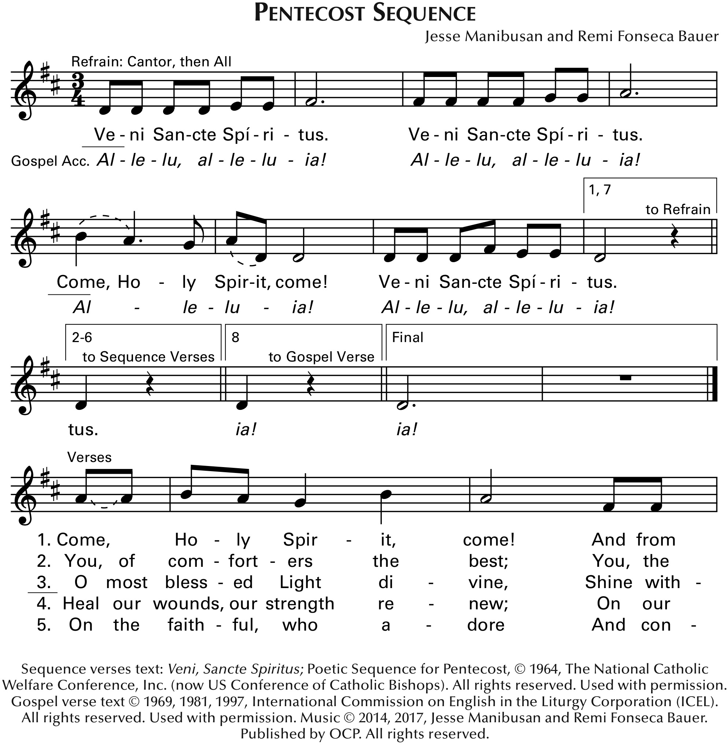

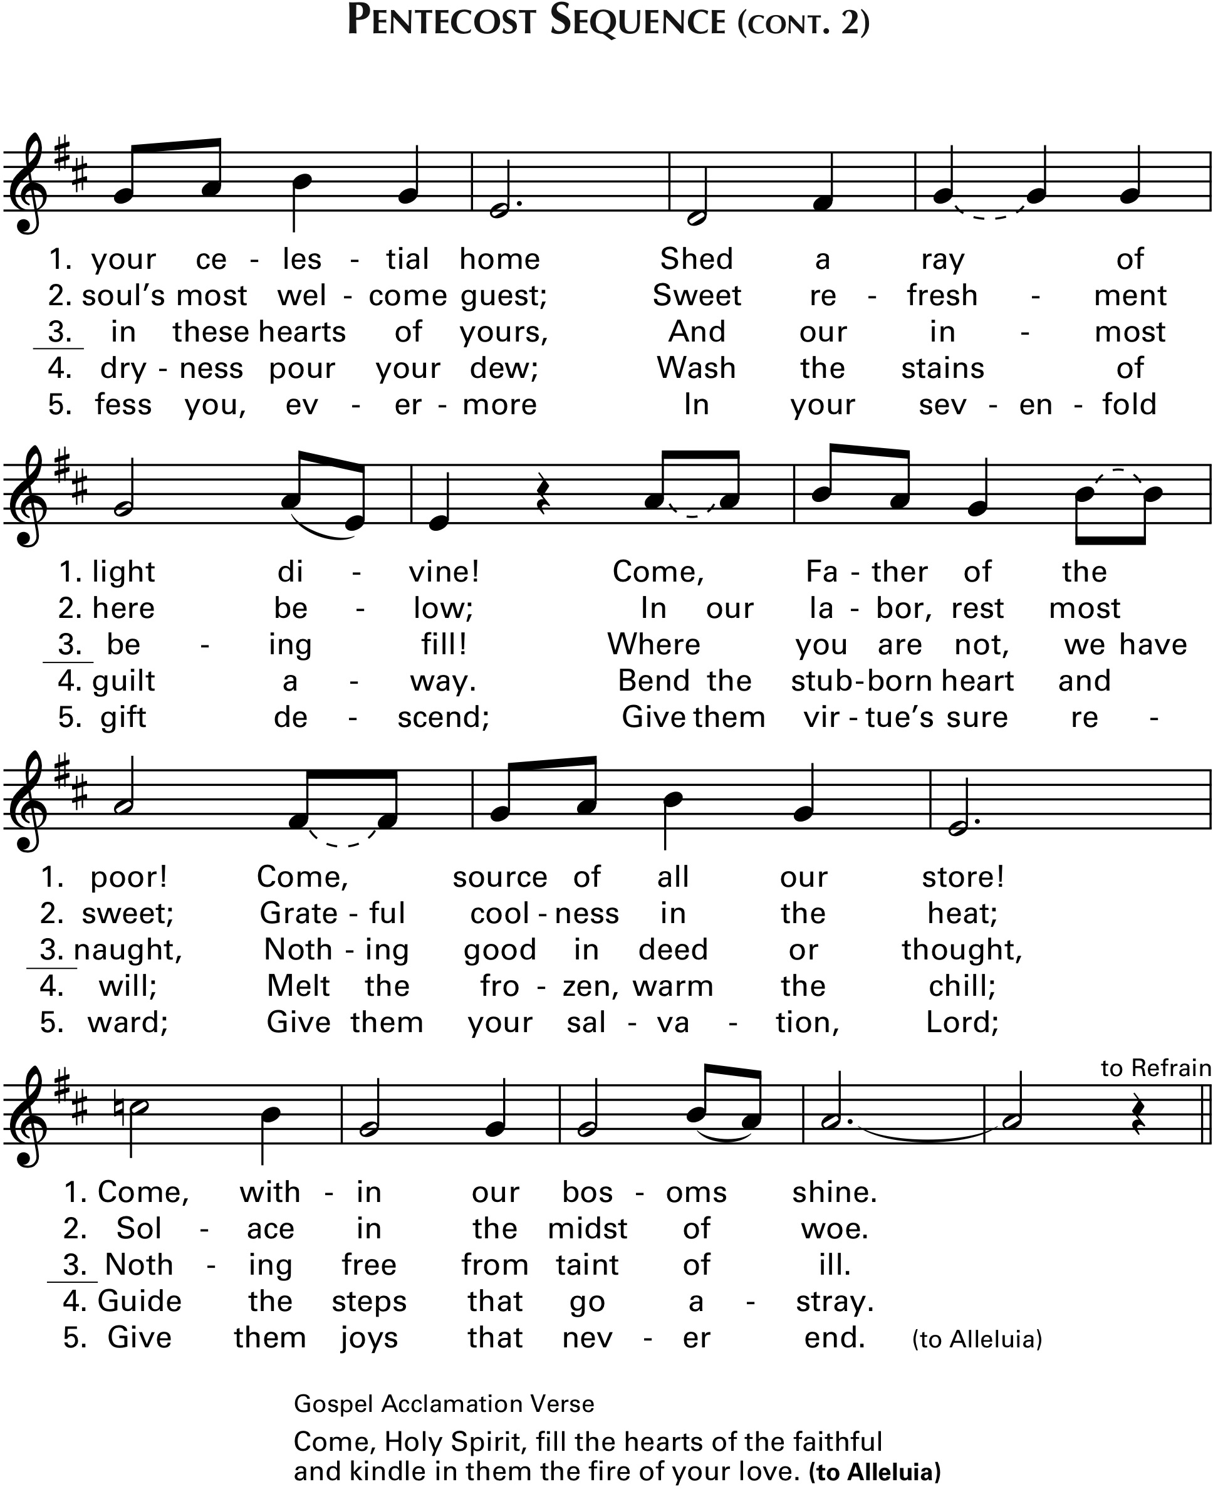

Gospel Acclamation from Pentecost Sequence
Jesse Manibusan and Remi Fonseca Bauer
Gospel verse text © 1969, 1981, 1997, International Commission on English in the Liturgy Corporation (ICEL).
All rights reserved. Used with permission.
Music © 2014, 2017, Jesse Manibusan and Remi Fonseca Bauer. Published by OCP.
All rights reserved. Reprinted under OneLicense.net #A-727260

Gospel John 20: 19 - 23

Homily

Nicene Creed
I believe in one God,
the Father almighty,
maker of heaven and earth,
of all things visible and invisible.
I believe in one Lord Jesus Christ,
the Only Begotten Son of God,
born of the Father before all ages.
God from God, Light from Light,
true God from true God,
begotten, not made, consubstantial with the Father;
through him all things were made.
For us men and for our salvation
he came down from heaven,
(All Bow) and by the Holy Spirit
was incarnate of the Virgin Mary,
and became man.
For our sake he was crucified under Pontius Pilate,
he suffered death and was buried,
and rose again on the third day
in accordance with the Scriptures.
He ascended into heaven
and is seated at the right hand of the Father.
He will come again in glory to judge the living and the dead
and his kingdom will have no end.
I believe in the Holy Spirit, the Lord, the giver of life,
who proceeds from the Father and the Son,
who with the Father and the Son
is adored and glorified,
who has spoken through the prophets.

I believe in one, holy, catholic and apostolic Church.
I confess one Baptism for the forgiveness of sins
and I look forward to the resurrection of the dead
and the life of the world to come. Amen.

Universal Prayer for Pentecost “Lord, hear our prayer.”

LITURGY OF THE EUCHARIST
Preparation of the Gifts 10:30 “Holy Spirit, Living Breath of God”
Keith and Kristyn Getty

Eucharistic Prayer
Acclamations from MASS OF CHRIST THE SAVIOR
Dan Schutte
Text © 2010, ICEL. All rights reserved. Used with permission. Music © 2007, 2009, Daniel L. Schutte.
Published by OCP. All rights reserved. Reprinted under OneLicense.net #A-727260.
“Holy, Holy”
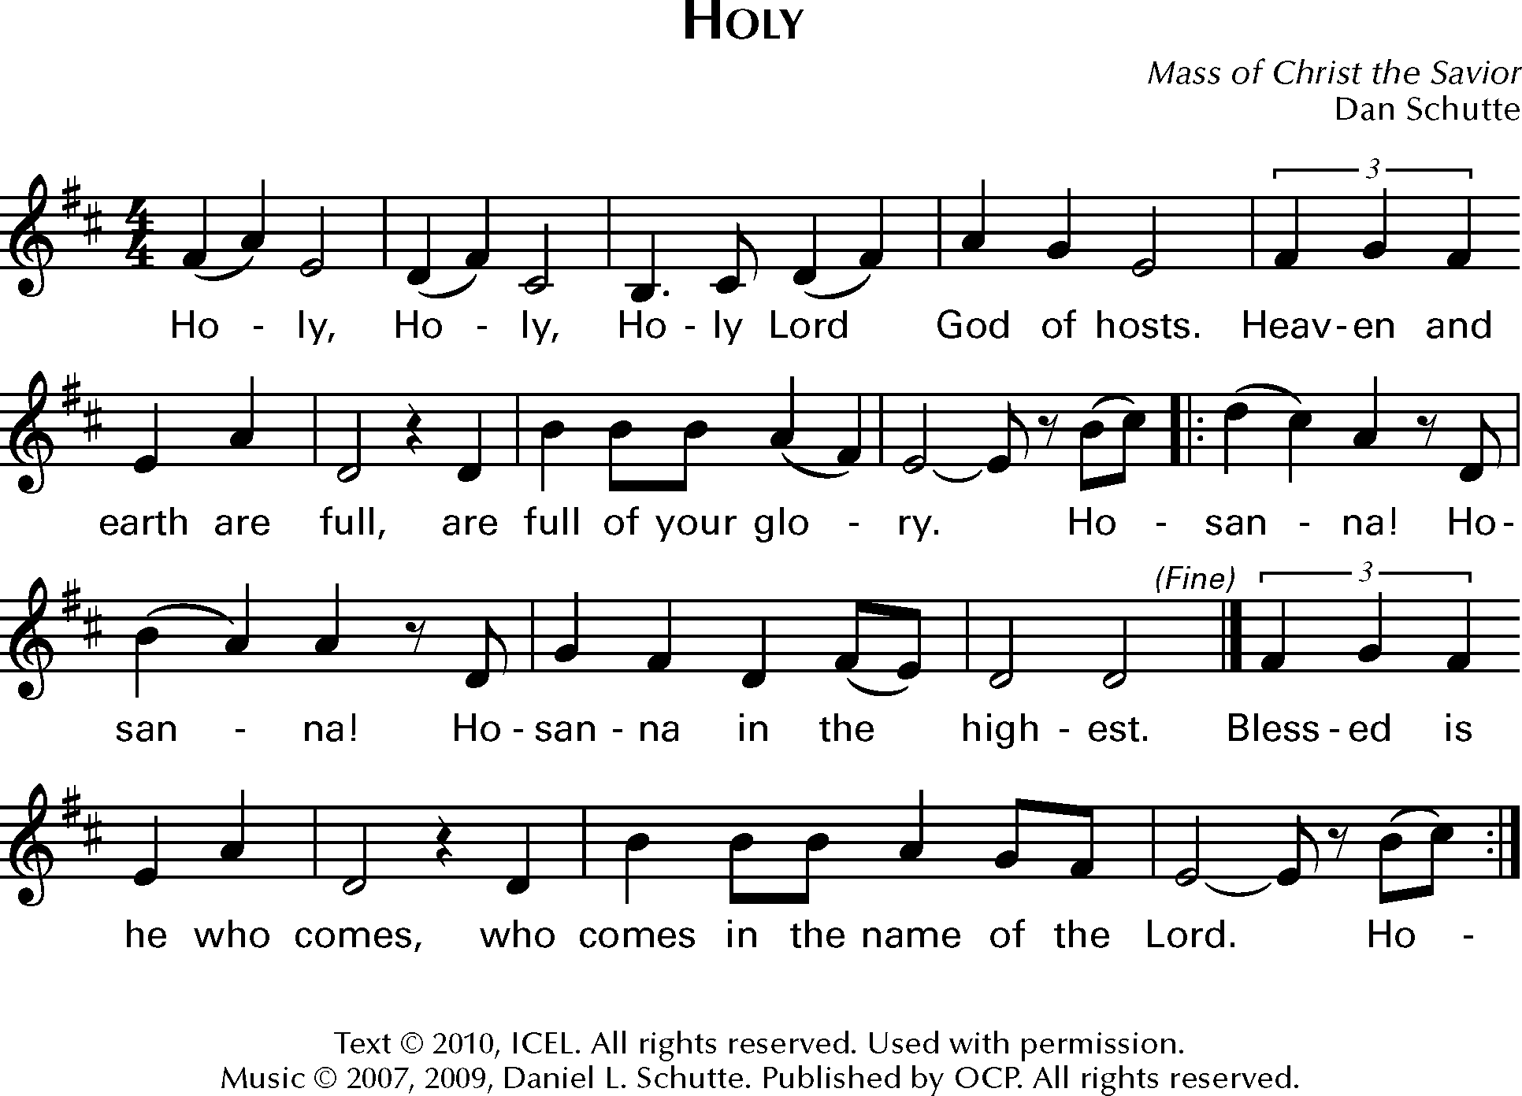

“Memorial Acclamation”
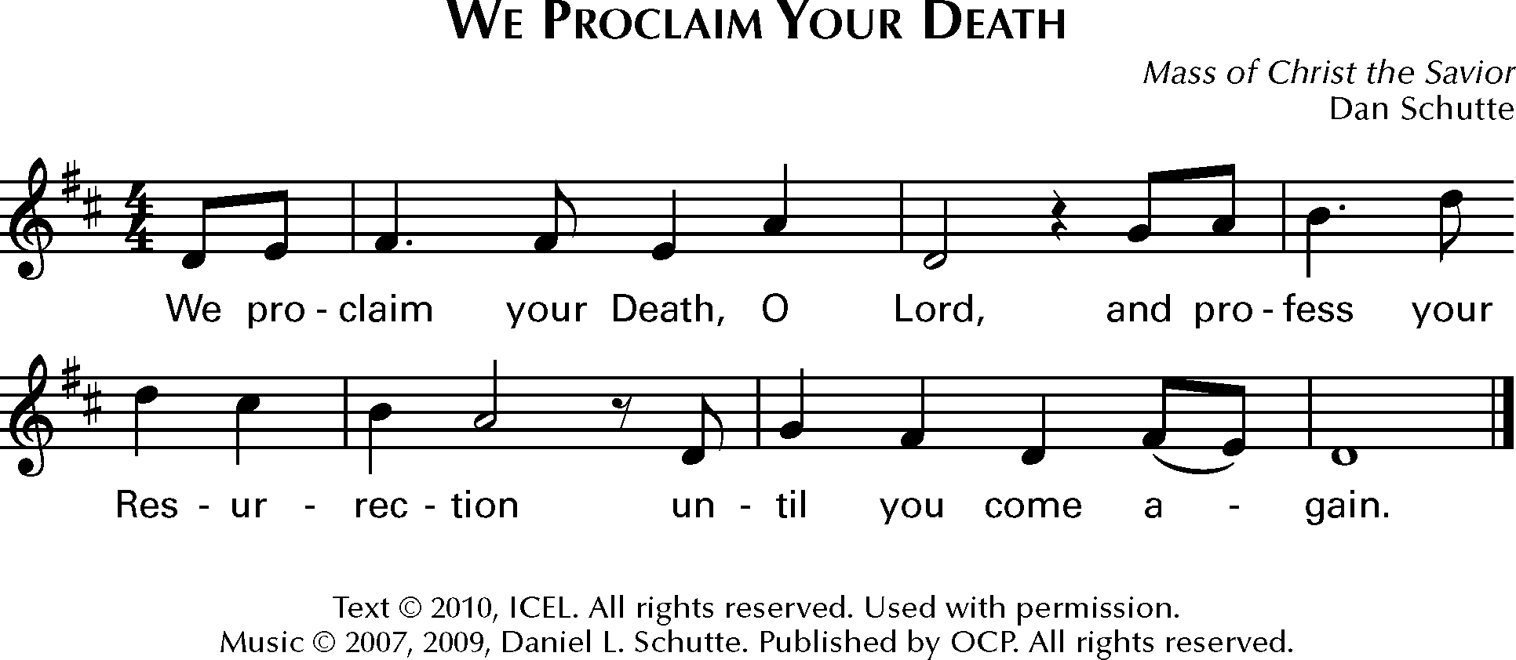

“Great Amen”
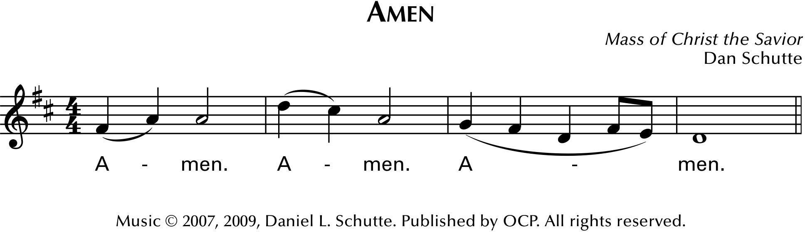
Communion Rite
The Lord’s Prayer

Sign of Peace

The Lamb of God
Acclamation from MASS OF CHRIST THE SAVIOR
Dan Schutte
Text © 2010, ICEL. All rights reserved. Used with permission. Music © 2007, 2009, Daniel L. Schutte.
Published by OCP. All rights reserved.
Reprinted under OneLicense.net #A-727260.
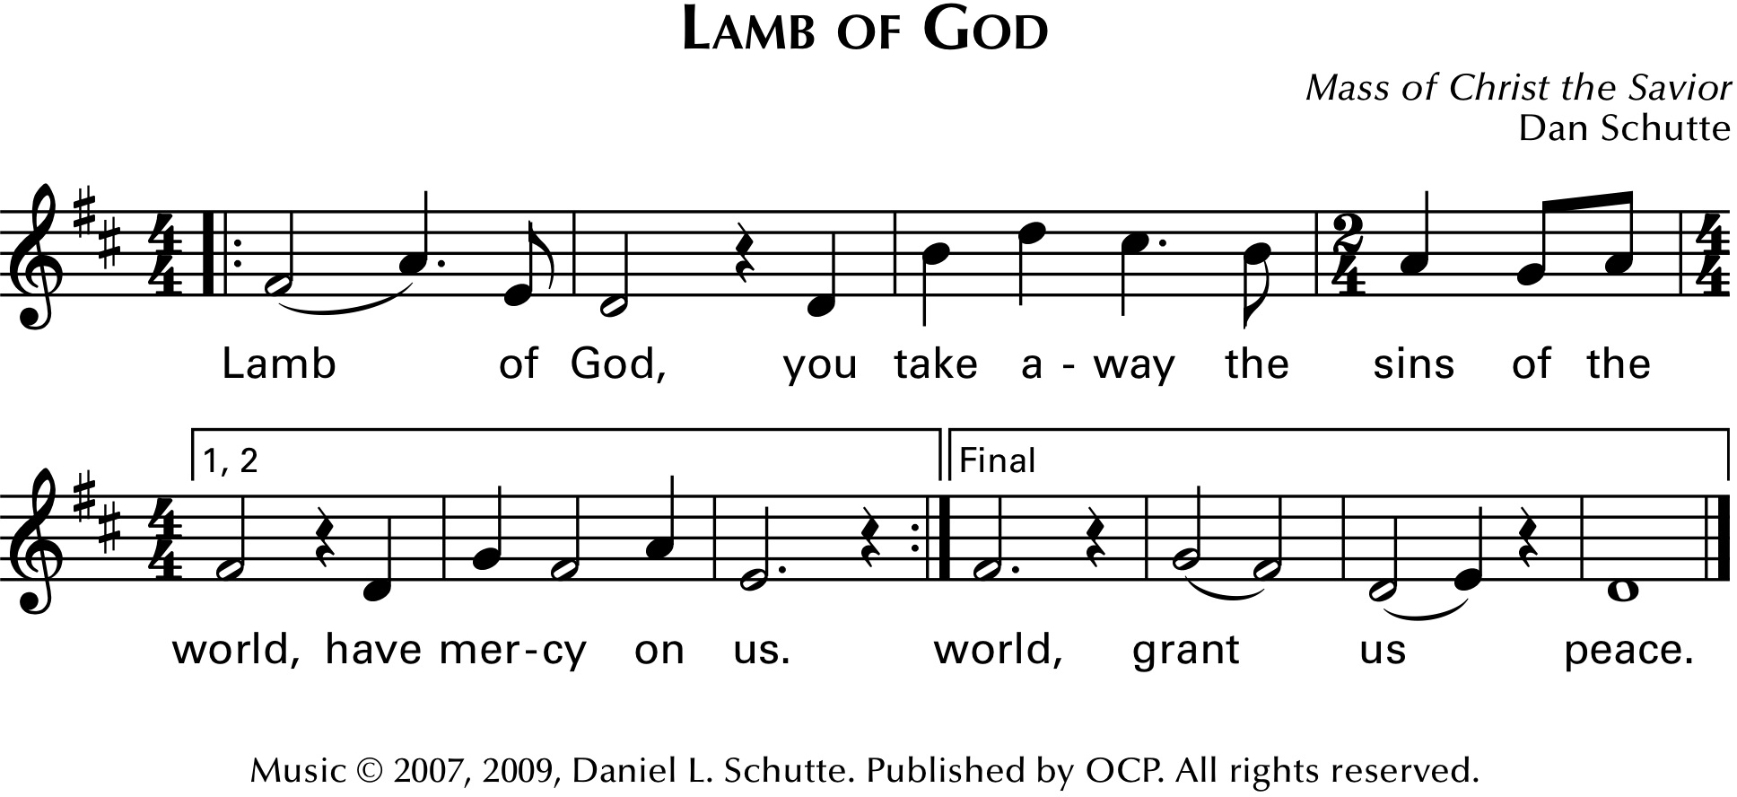

COMMUNION PROCESSION
Communion Antiphon “Pentecost”
Steve Angrisano, Sarah Hart, and Curtis Stephen
Text: ©2010, ICEL. All rights reserved. Used with permission.
© 2020, Steve Angrisano, Sarah hart, and Curtis Stephan. Published by OCP.
All rights reserved. Used with permission. Reprinted under OneLicense.net #A-72726 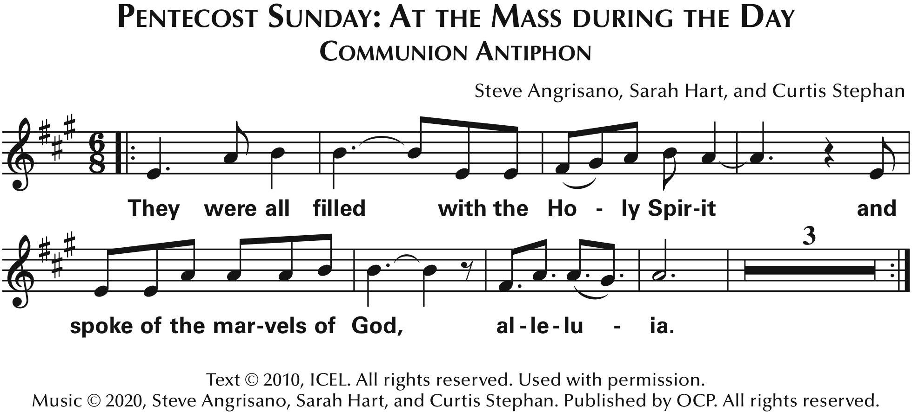
Communion Song “Spirit and Grace”
Ricky Manalo
Breaking Bread, Number 362
© 2006, Ricky Manalo, CSP. Published by OCP. All rights reserved.
Reprinted under OneLicense.net #A-727260
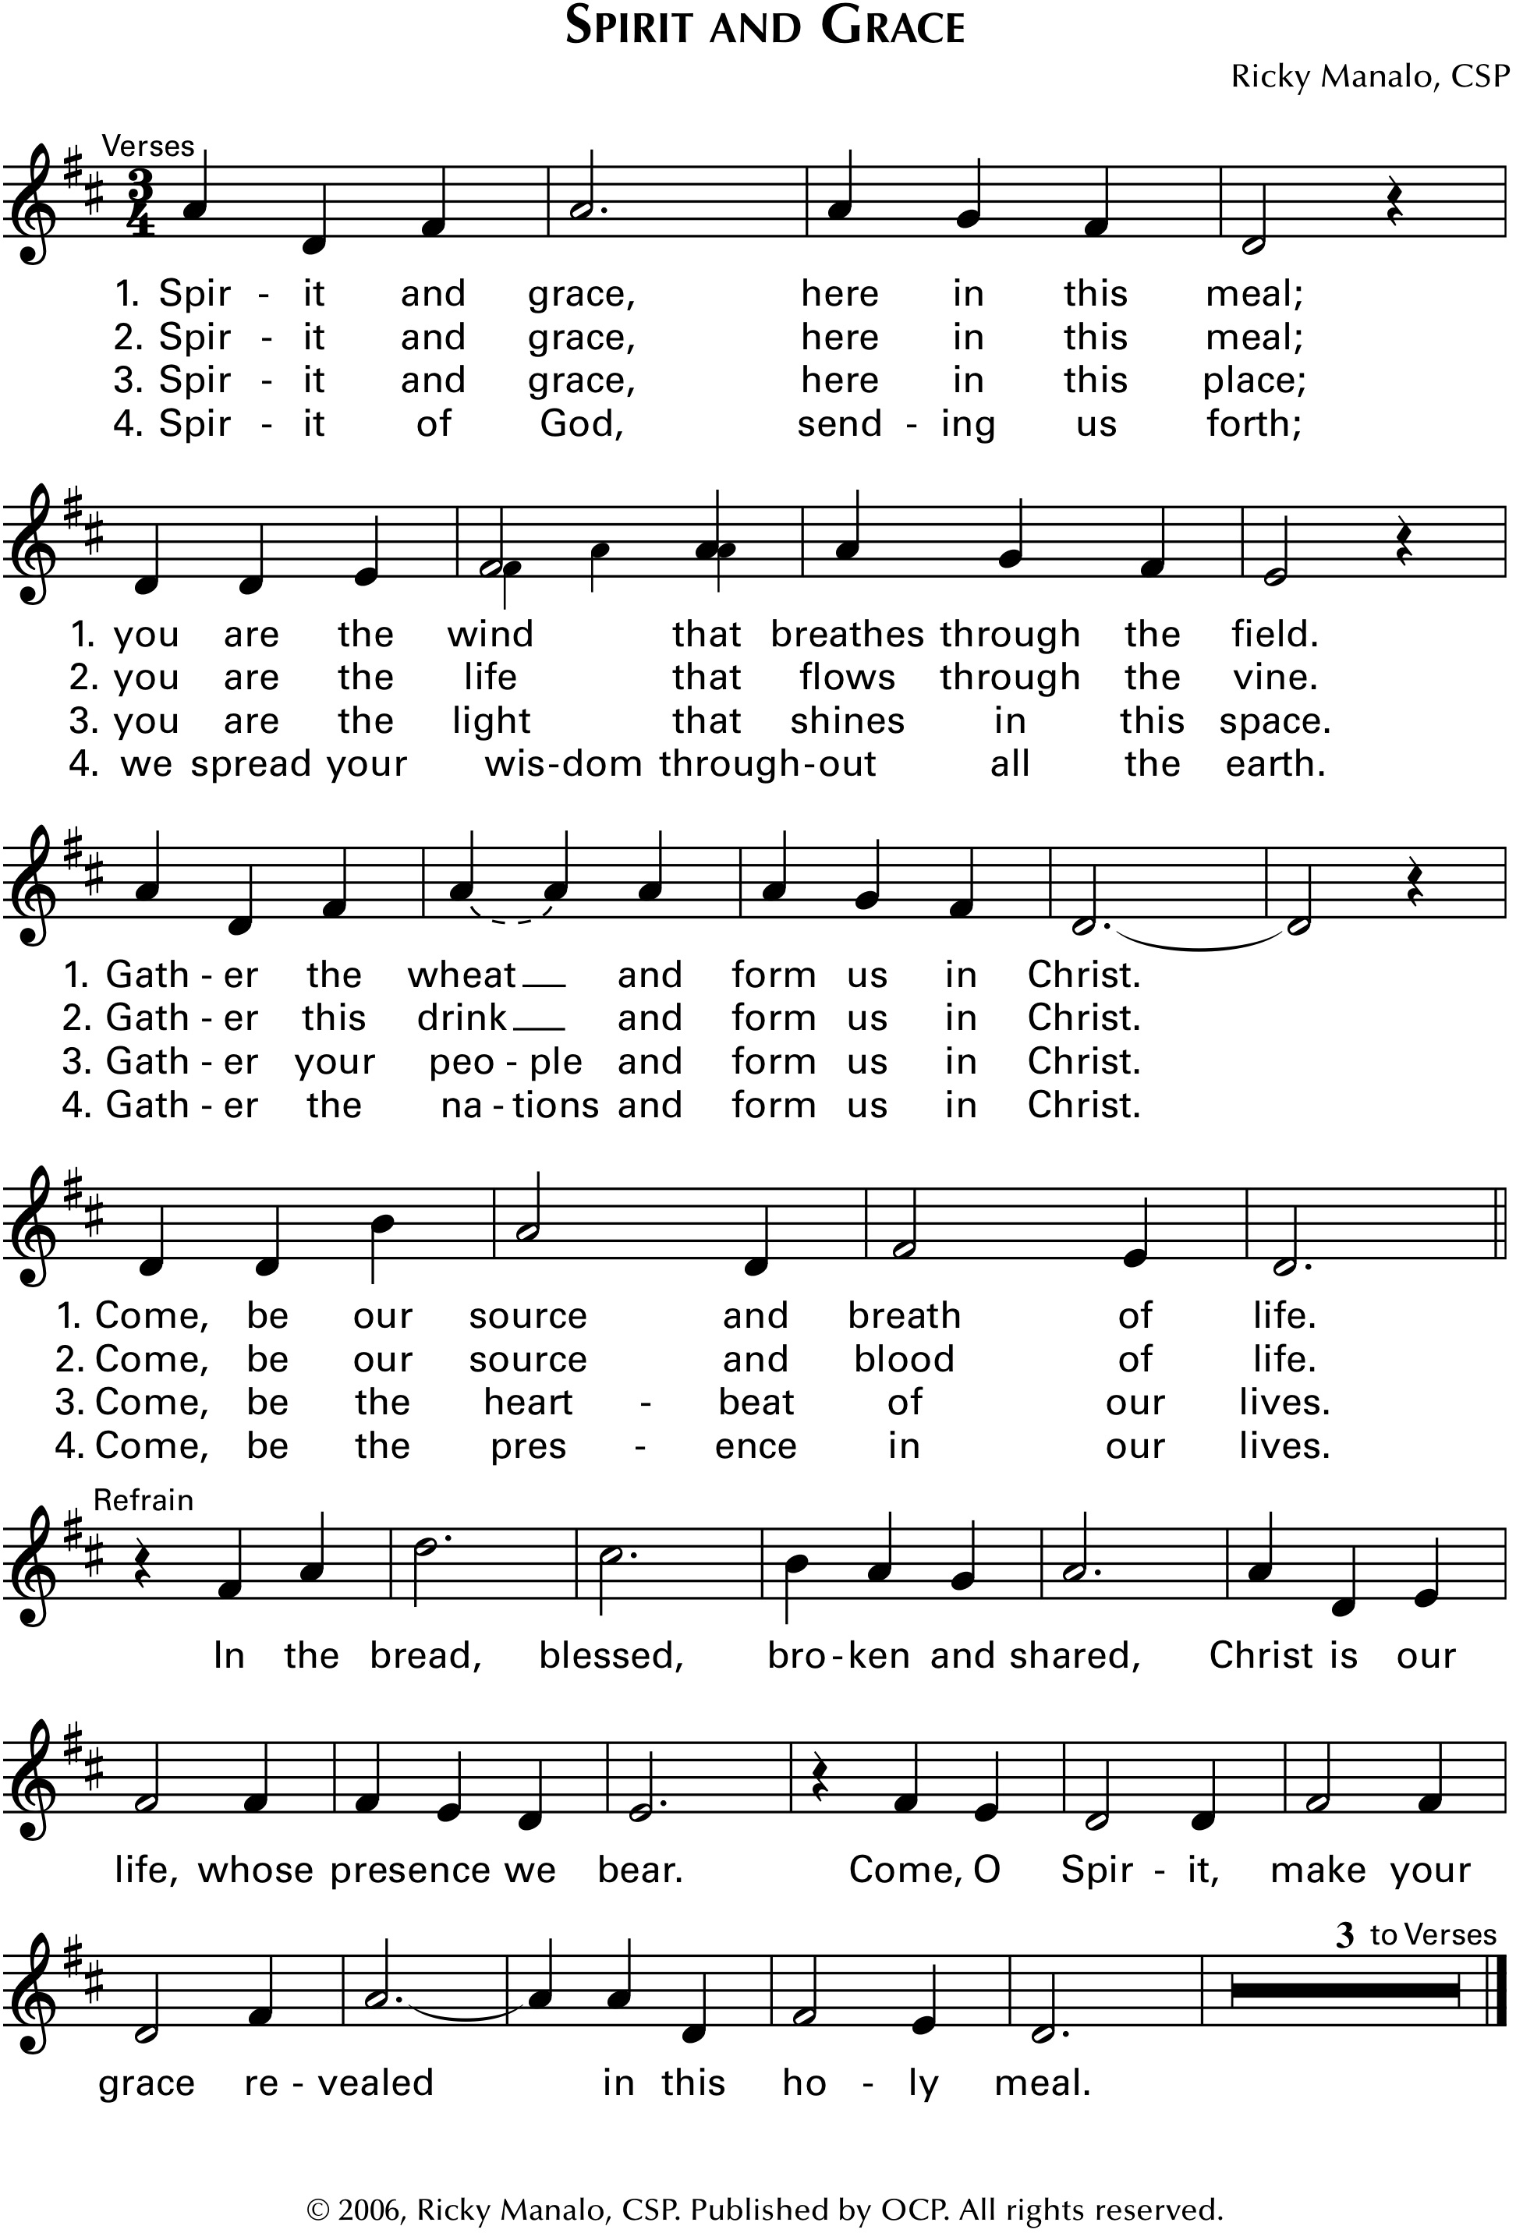

ANNOUNCEMENTS:
Musician –
If you are having a medical procedure or surgery soon, please meet the priest at the Reconciliation Room for the Anointing of the Sick after he greets parishioners.

Our Cornerstone Breakfast has arrived early this month! Please join us in the gym after Mass today to enjoy our tasty breakfast buffet.

Calling all moms! Next Saturday at 4 is our Holy Mamas monthly craft night! Join us in the Holy Mamas room with any craft of your choosing for a social hour with other moms.

Prayer after Communion

Prayer for Vocations
Please join in praying for vocations.
The prayer is found on the card inserted
in the Breaking Bread books…

Loving and Generous God,
it is You who call us by name
and ask us to follow You.

Help us to grow in the Love and Service
of our Church as we experience it today,
and give us the energy and courage of Your Spirit
to shape its future.

Grant us faith-filled leaders,
who will embrace Christ's mission
of love and justice.
Bless the Parish of St. Michael Poplar Springs,
by raising up dedicated and generous leaders
from our families and friends
who will serve Your people as Sisters, Priests, Brothers, Deacons, and Lay Ministers.

Inspire us to know You better
and open our hearts to hear Your call.
We ask this through Christ our Lord. Amen.

Solemn Blessing (The Holy Spirit)

Dismissal Either…

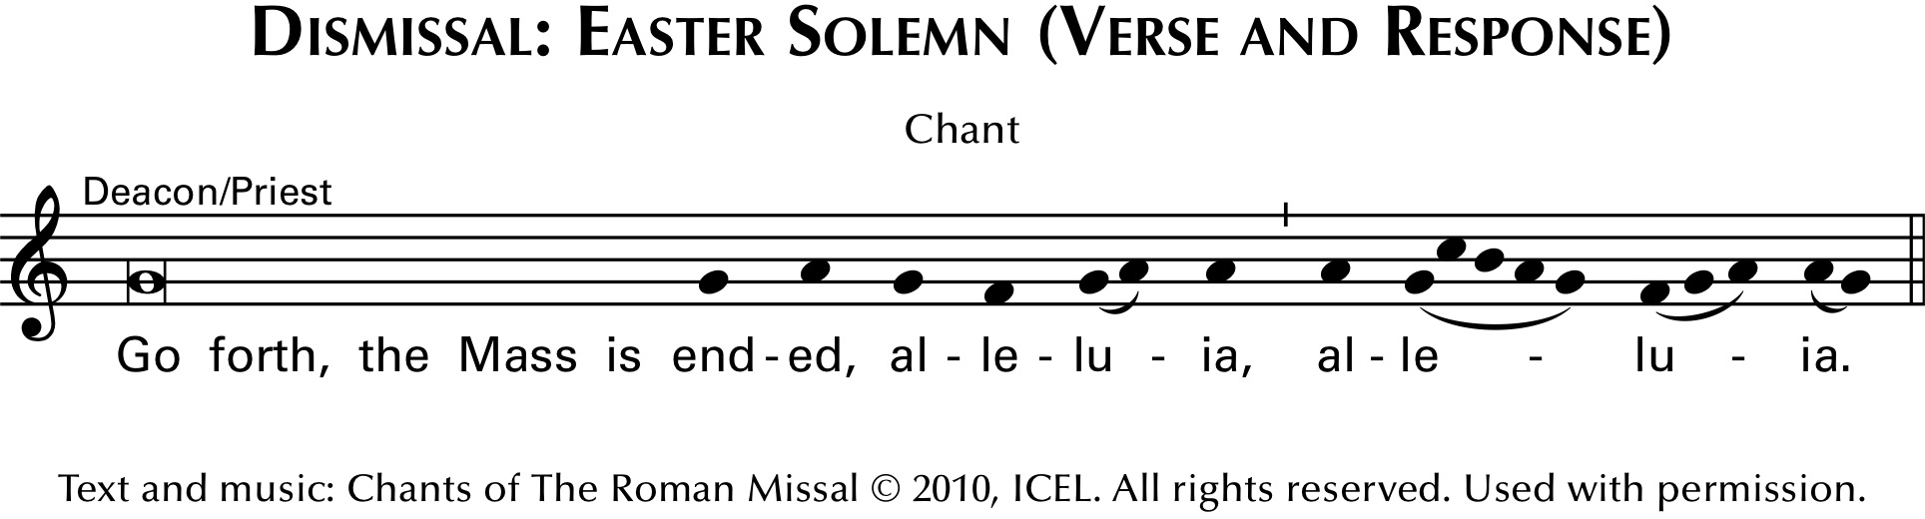
or…
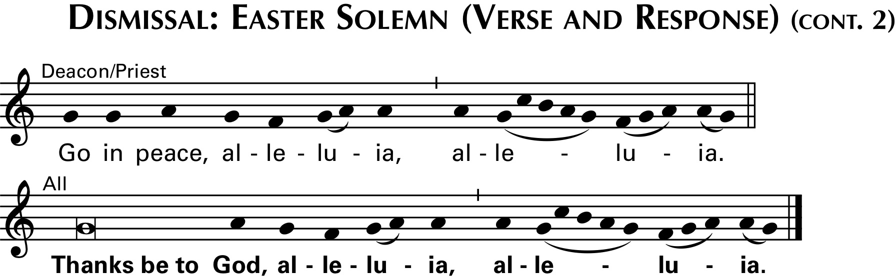

All respond…

Sending Forth 10:30 “All That We Have Seen”
Sarah Hart
Breaking Bread Book, Number 385
© 2019, Sarah Hart. Published by Spirit & Song®, a division of OCP. All rights reserved.
Reprinted under OneLicense.net #A-727260
