**THE SOLEMNITY OF**

**THE MOST HOLY TRINITY**

**May 25/26, 2024**

Klismet (Cliff)

St. Michael Poplar Springs

Mount Airy, MD

10:30 a.m. in church will be live-streamed.

**Prelude 10:30 “King of Kings”***CMM Notebook – C90*

*Brooke Ligertwood, Jason Ingram, Scott Ligertwood*

*CCLI Song #7127647*

*© 2019 Hillsong Music Publishing Australia; Fellow Ships Music; So Essential Tunes*

*For use solely with the SongSelect® Terms of Use. All rights reserved. www.ccli.com*

*CCLI License #2372259*

*Verse 1*

*In the darkness we were waiting*

*Without hope without light*

*Till from Heaven You came running*

*There was mercy in Your eyes*

*To fulfil the law and prophets*

*To a virgin came the Word*

*From a throne of endless glory*

*To a cradle in the dirt*

*Chorus*

*Praise the Father*

*Praise the Son*

*Praise the Spirit three in one*

*God of Glory*

*Majesty*

*Praise forever to the King of kings*

*Verse 2*

*To reveal the kingdom coming*

*And to reconcile the lost*

*To redeem the whole creation*

*You did not despise the cross*

*For even in Your suffering*

*You saw to the other side*

*Knowing this was our salvation*

*Jesus for our sake You died*

*Verse 3*

*And the morning that You rose*

*All of heaven held its breath*

*Till that stone was moved for good*

*For the Lamb had conquered death*

*And the dead rose from their tombs*

*And the angels stood in awe*

*For the souls of all who'd come*

*To the Father are restored*

*Verse 4*

*And the Church of Christ was born*

*Then the Spirit lit the flame*

*Now this Gospel truth of old*

*Shall not kneel shall not faint*

*By His blood and in His Name*

*In His freedom I am free*

*For the love of Jesus Christ*

*Who has resurrected me*

**MUSICIAN: Good evening/morning/afternoon! Welcome to St. Michael Poplar Springs! Today we celebrate the Solemnity of the Holy Trinity.**

**10:30 – Welcome to all who join us via livestream! You will find a worship aid for your use at our web page.**

**ALL MASSES:**

**The Easter Season ended with the celebration of Pentecost last Sunday. As we begin Ordinary Time you’ll notice the change in the setting we sing of the “Glory to God” and the Eucharistic Acclamations. We return to “The Glendalough Mass” today and will continue to use it through most of the summer months. This is not included in the Breaking Bread books, but it is on the memories of many parishioners. There will be copies of this Mass setting available at the Welcome Desk, should you want to have access to the music. Simply return it after Mass each week.**

**Before Mass begins,**

**let us all take a moment to silence our mobile devices**

**and come to a quiet awareness of God’s presence here,**

**remembering the needs of our loved ones and our world,**

**giving thanks for the many blessings we have received this week.**

**< PLEASE PAUSE to “remember.”>**

**Please stand and offer welcome to those around you…**

**Today our presider is:**

**10:30 – Father Kurt. He is assisted by Deacon Cliff.**

**10:30 – Please turn in the CMM Notebook to song C20 – “How Great Is Our God,” C20. Let us sing together!**

**INTRODUCTORY RITES**

**Gathering Song 10:30 “How Great Is Our God”**

*CMM Notebook – C20*

**Greeting**

**Sign of the Cross**

**Penitential Act**

**Gloria “Glory to God”** from *Glendalough Mass*

*Liam Lawton*

Tune: © 2010, GIA Publications, Inc. All rights reserved.

Used with permission. Reprinted under OneLicense.net #A-727260

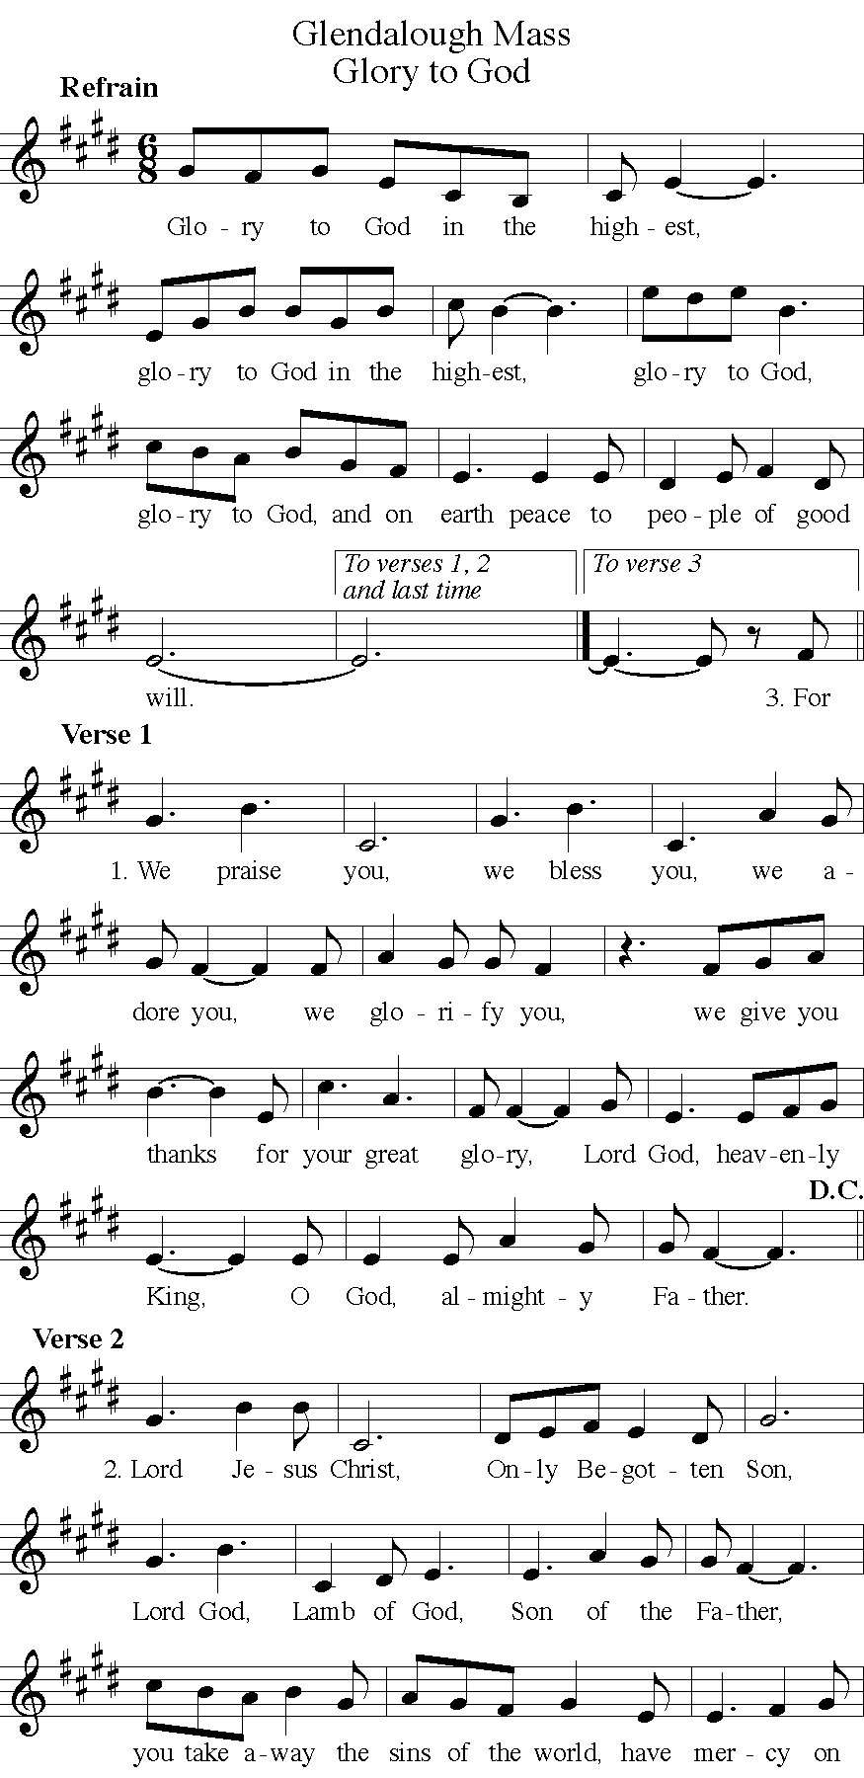



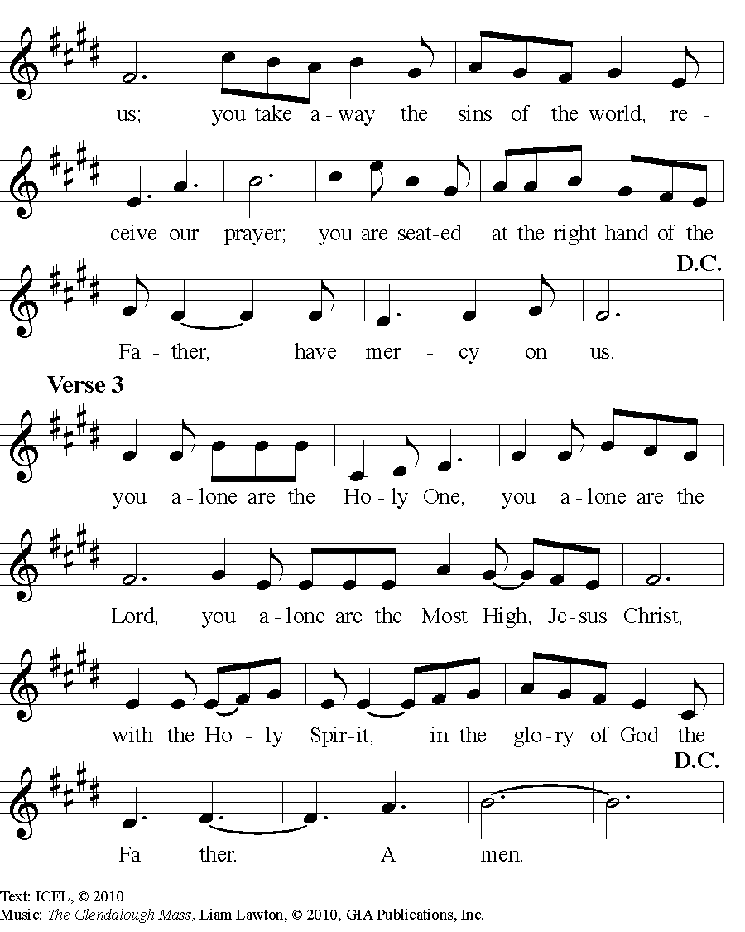

**Collect**

**LITURGY OF THE WORD**

**First Reading Deuteronomy 4: 32 – 34, 39- 40**

**Responsorial Psalm Psalm 33:**

**“Blessed the People the Lord Has Chosen to Be His Own”**

*Jackie François*

Text © 1969, 1981, 1997, ICEL. All rights reserved. Used with permission.

Music © 2016, 2017, Jackie François. Published by OCP. All rights reserved.

All rights reserved. Reprinted under OneLicense.net #A-727260

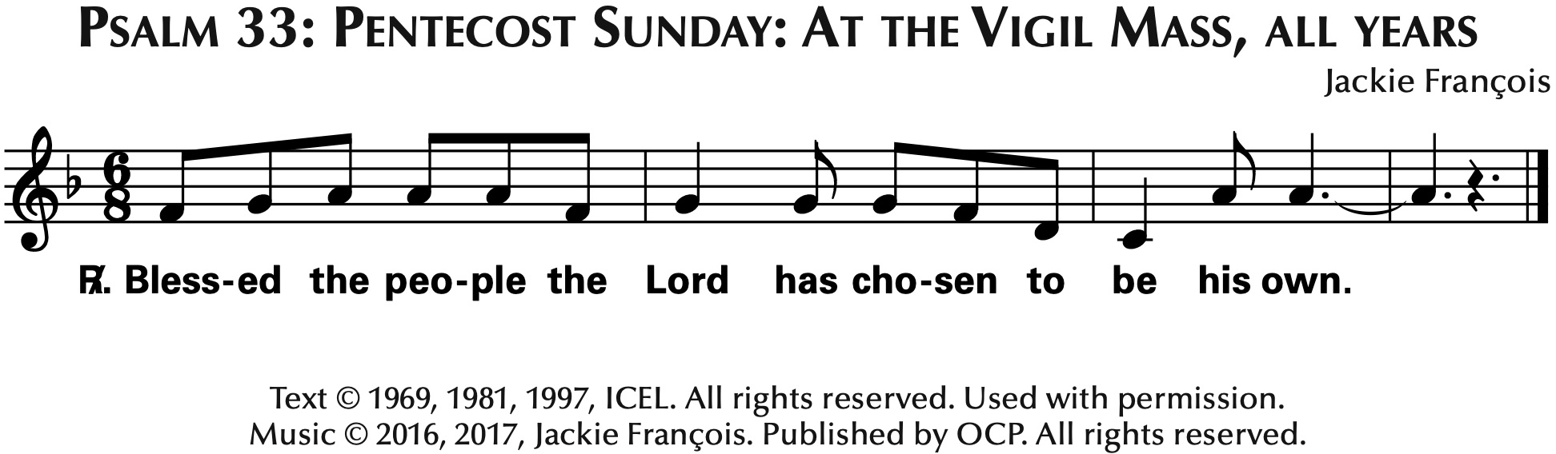

**Second Reading Romans 8: 14 - 17**

**Gospel Acclamation from *Mass in the Desert***

*Tom Booth*

Music © 2011, Tom Booth. Published by OCP. All rights reserved.

All rights reserved. Reprinted under OneLicense.net #A-727260

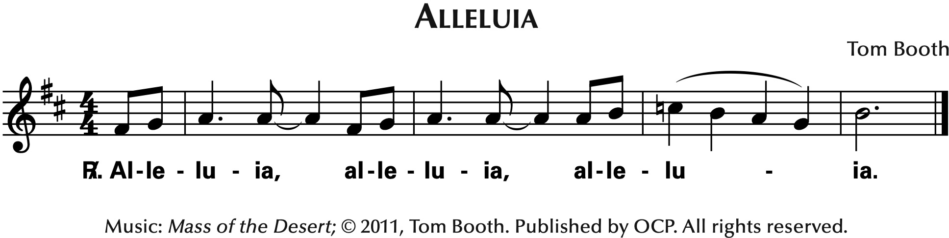

**Gospel Matthew 28: 16 - 20**

**Homily**

**Nicene Creed**

I believe in one God,  
the Father almighty,  
maker of heaven and earth,  
of all things visible and invisible.

I believe in one Lord Jesus Christ,  
the Only Begotten Son of God,  
born of the Father before all ages.

God from God, Light from Light,

true God from true God,  
begotten, not made, consubstantial with the Father;

through him all things were made.

For us men and for our salvation

he came down from heaven,

*(All Bow)* and by the Holy Spirit was incarnate of the Virgin Mary,

and became man.

For our sake he was crucified under Pontius Pilate,  
he suffered death and was buried,  
and rose again on the third day  
in accordance with the Scriptures.

He ascended into heaven and is seated at the right hand of the Father.

He will come again in glory to judge the living and the dead  
and his kingdom will have no end.

I believe in the Holy Spirit, the Lord, the giver of life,  
who proceeds from the Father and the Son,  
who with the Father and the Son

is adored and glorified,  
who has spoken through the prophets.

I believe in one, holy, catholic and apostolic Church.

I confess one Baptism for the forgiveness of sins

and I look forward to the resurrection of the dead

and the life of the world to come. Amen.

Universal Prayer respond **“Lord, hear our prayer.”**

**LITURGY OF THE EUCHARIST**

**Preparation of the Gifts**  5/8/12:15 “Creator, Beloved and Spirit”

*Bob Moore*

*MUSICIANS only*

**Preparation of the Gifts**  10:30 “The Potter’s Hand”

*CMM Notebook, C-40*

*Darlene Zschech*

CCLI Song #2449771

© 1997 Wondrous Worship

For use solely with the SongSelect® Terms of Use. All rights reserved. www.ccli.com

CCLI License #2372259

Verse 1

Beautiful Lord wonderful Saviour

I know for sure all of my days are

Held in Your hand crafted into

Your perfect plan

Verse 2

You gently call me into Your presence

Guiding me by Your Holy Spirit

Teach me dear Lord to live all of my life

Through Your eyes

Pre-Chorus

I'm captured by Your holy calling

Set me apart I know You're drawing

Me to Yourself

Lead me Lord I pray

Chorus

Take me mould me

Use me fill me

I give my life

To the Potter's hand

Call me guide me

Lead me walk beside me

I give my life

To the Potter's hand

Ending

Ooo ooo ooo

**Eucharistic Prayer Acclamations from GLENDALOUGH MASS**

*Liam Lawton*

Tune: © 2010, GIA Publications, Inc. All rights reserved.

Used with permission. Reprinted under OneLicense.net #A-727260

“Holy, Holy”

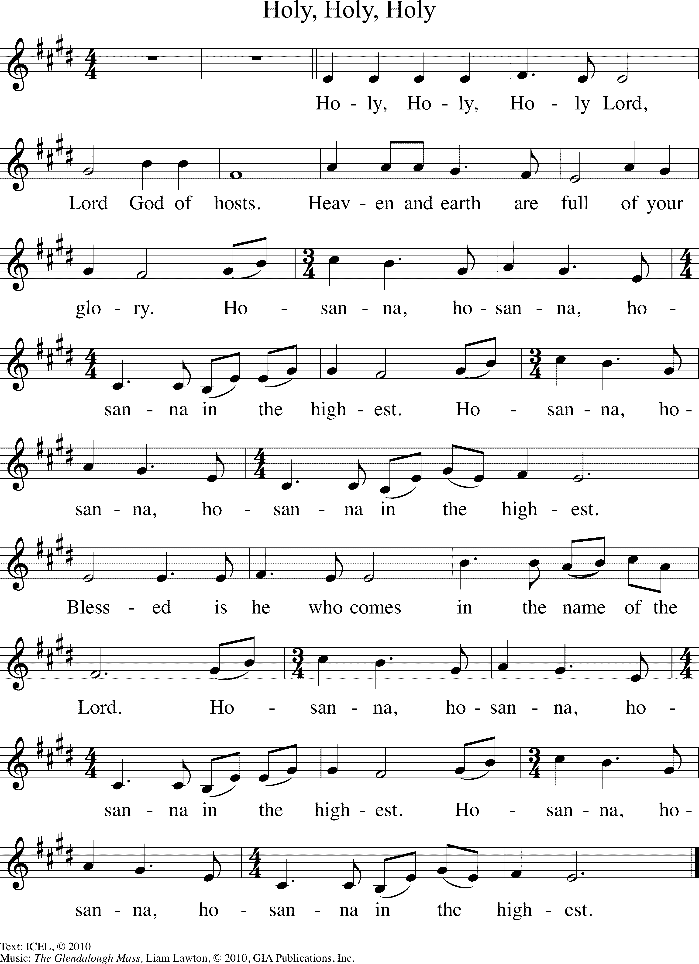

“Memorial Acclamation”

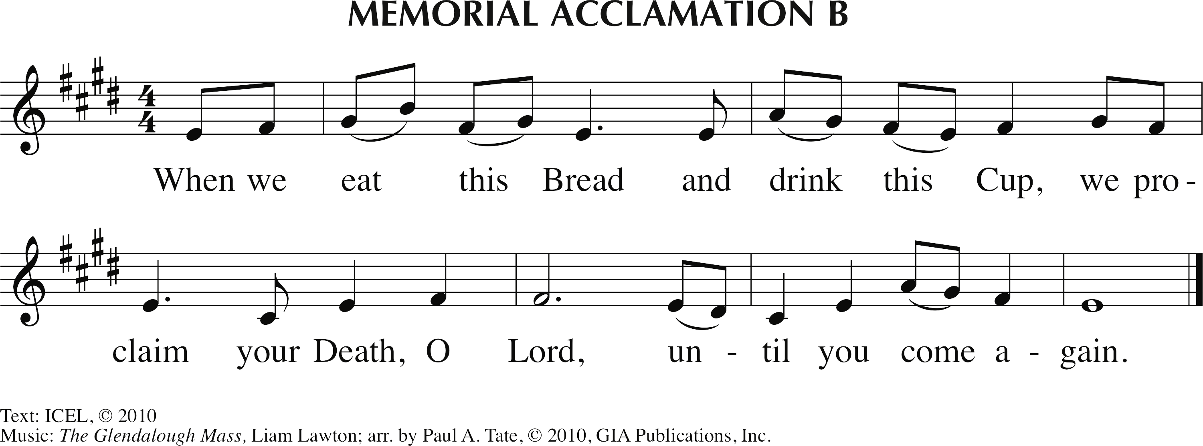

“Great Amen”

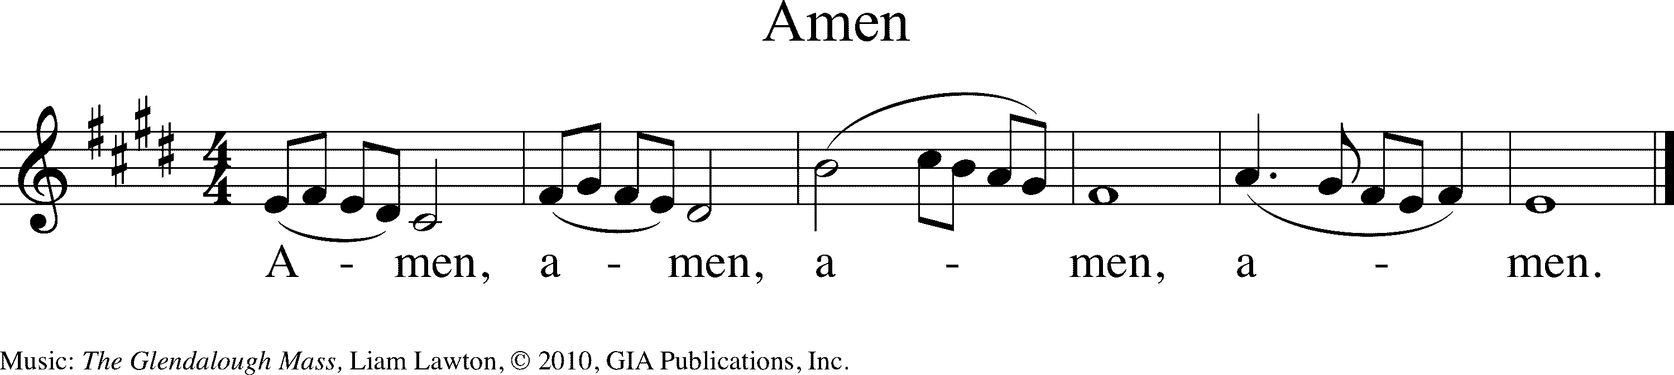

**Communion Rite**

**The Lord’s Prayer**

**Sign of Peace**

**The Lamb of God**

**Acclamation from GLENDALOUGH MASS**

*Liam Lawton*

Tune: © 2010, GIA Publications, Inc. All rights reserved.

Used with permission. Reprinted under OneLicense.net #A-727260 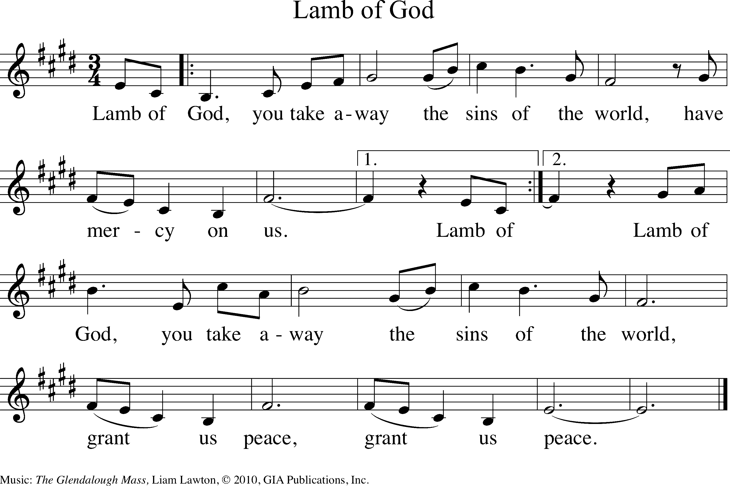

**COMMUNION PROCESSION**

**Communion Antiphon “Holy Trinity”**

*Steve Angrisano, Sarah Hart, and Curtis Stephen*

Text: ©2010, ICEL. All rights reserved. Used with permission.

© 2020, Steve Angrisano, Sarah hart, and Curtis Stephan. Published by OCP.

All rights reserved. Used with permission. Reprinted under OneLicense.net #A-72726 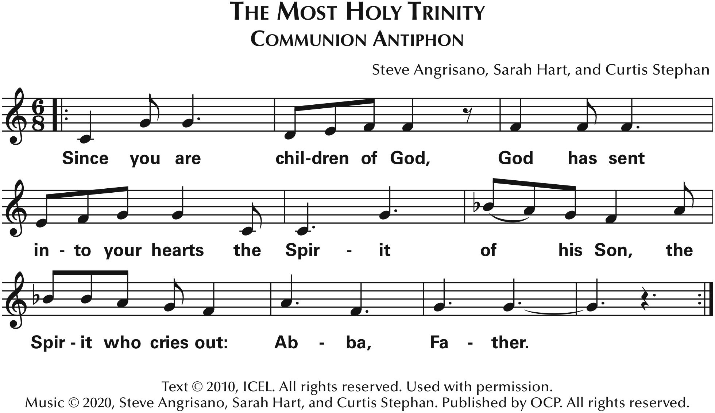

**Communion Song 10:30 “Send Me”**

*Song sheet*

*Brandon Lake, Jenn Johnson, Kari Jobe*

*CCLI Song #7183261*

*© 2020 Brandon Lake Music; Brian and Jenn Publishing; Maverick City Publishing Worldwide; Kari Jobe Carnes Music; Worship Together Music; Bethel Music Publishing*

*For use solely with the SongSelect® Terms of Use. All rights reserved. www.ccli.com*

*CCLI License #2372259ANNOUNCEMENTS:*

*Verse 1*

*If it’s bandaging the broken or washing filthy feet*

*Here I am Lord send me*

*If it’s loving one another even when we don’t agree*

*Here I am Lord send me*

*Verse 2*

*If I’m poor or if I’m wealthy*

*I’ll serve You just the same*

*Here I am Lord send me*

*On the mountain or the valley*

*I will choose to praise*

*Here I am Lord send me*

*Chorus*

*If I’m known by how I love let my life reflect*

*How much I love You I love You*

*And before You even ask oh my answer will be yes*

*‘Cause I love You I love You*

*Verse 3*

*If the truth cuts like an arrow I will say it anyway*

*‘Cause here I am Lord send me*

*If it’s means that they’ll reject me*

*Lord I will still obey*

*Here I am Lord send me*

*Verse 4*

*When I’m standing in Your glory*

*I’ll be glad I chose to say*

*Here I am Lord send me*

*Well done good and faithful I live to hear You say*

*Here I am Lord send me*

*Tag*

*Here I am Lord send me*

*Here I am Lord send me*

**ANNOUNCEMENTS**

*Musician –*

*If you are having a medical procedure or surgery soon, please meet the priest at the Reconciliation Room for the Anointing of the Sick after he greets parishioners.*

*Please enjoy a safe an happy Memorial Day Weekend. Remember that the parish offices are closed on Monday for the holiday and there will NOT be morning Mass on Monday.*

*SUNDAY MASSES ONLY*

*We now welcome Jason Wisniewski to come forward to tell us about several upcoming Young Adult opportunities.*

**Prayer for Vocations**

***Please join in praying for vocations.***

***The prayer is found on the card inserted in the Breaking Bread books…***

**Loving and Generous God,**

**it is You who call us by name**

**and ask us to follow You.**

**Help us to grow in the Love and Service**

**of our Church as we experience it today,**

**and give us the energy and courage of Your Spirit**

**to shape its future.**

**Grant us faith-filled leaders,**

**who will embrace Christ's mission**

**of love and justice.**

**Bless the Parish of St. Michael Poplar Springs,**

**by raising up dedicated and generous leaders**

**from our families and friends**

**who will serve Your people as Sisters, Priests, Brothers, Deacons, and Lay Ministers.**

**Inspire us to know You better**

**and open our hearts to hear Your call.**

**We ask this through Christ our Lord. Amen.**

**Dismissal**

**Closing Song 10:30 “The Lord’s Prayer”**

*Songsheet*